

**Adama Science and Technology University**

**School of Electrical Engineering and Computing**

**Department of Computer Science and Engineering**

**Internship Report**

**Name:** Leul Gedion

**ID:** UGR/25630/14

**Department Supervisor:** Dr. Getinet Yilma

**Hosting Organization:** IE Network Solutions

**Hosting Organization Supervisor:** Ms. Selamawit Getaneh

**Duration of Internship:** 2 Months

**Submission date:** 23/09/2024

# Executive summary

This report examines the effectiveness of the internship program at **IE Network Solutions**, with the objective of understanding its goals, exploring the organizational background, explaining its key objectives, providing an overview of the relevant department, analyzing the outcomes achieved, and concluding with practical recommendations. Moreover, this report aims to shed light on the methods employed for data collection, thoroughly analyze the challenges encountered along with their corresponding solutions, and engage in a meaningful discussion of the organization's overarching mission and vision.

In addition, this research delves into the broader purpose of the internship program at **IE Network Solution**, focusing on how it aligns with the company's strategic goals, its contributions to intern development, and its impact on organizational growth. Through in-depth analysis and discussion, the report offers insights into how the internship experience contributes to both personal and professional development while advancing the company's mission and vision.

# Acknowledgment

We would like to extend our heartfelt gratitude to **Adama Science and Technology University** for facilitating this enriching two-month internship experience. Additionally, we express our sincere thanks to **IE Network Solutions** for providing us with the invaluable opportunity to participate in their esteemed internship program.

A special acknowledgement is owed to **Ms. Selamawit Getaneh** for helping us seize the opportunity to embark on this internship journey and for her unwavering support throughout the process. Her thoughtful guidance, encouragement, and constant availability for advice have been invaluable to our progress. Ms. Selamawit's dedication to nurturing our growth and her insightful feedback have been instrumental in shaping our learning experience during this internship.

Our profound appreciation goes out to the entire team at **IE Network Solutions** for their unwavering guidance and for generously sharing their expertise. Their consistent motivation, from the program's inception to its conclusion, has greatly contributed to our learning and development.

Lastly, we would like to express our sincere thanks to our advisor, **Dr. Getinet Yilma** His unwavering support, invaluable advice, and thoughtful feedback have been vital in our professional growth.

# Acronyms

* MOST: - Ministry of Science and Technology
* ASTU: - Adama Science and Technology University
* SaaS: - Software as a Service
* HR: - Human Resource
* MOE: - Ministry of Education

**Table of Contents**

**Executive summary 2**

**Acknowledgment 3**

**Acronyms 4**

**Chapter 1: Introduction 6**

1.1 General overview 6

1.1.1 Objective of internship 6

1.1.2 Scope of the work expected 7

1.1.3 Outputs expected 7

1.2 Background of the organization 8

1.2.1 Description of the organization 8

1.2.2 Mission of the organization 8

1.2.3 Products/ services of the organization 9

**Chapter 2: Management, training, and employee information 9**

2.1 Major duty 9

2.2 Orientation of responsibilities 10

2.3 Supervisor ensures 11

2.4 Qualities Developed 12

**Chapter 3: Specific Job Information 13**

3.1 Technical duties 13

3.2 Other responsibilities 14

3.3 Technical knowledge 15

3.4 Relevant projects 16

**Chapter 4: Reflection and Conclusion 23**

4.1 Evaluation and Critique 23

4.2 Career goal during internship 23

4.3 Value of internship 24

4.4 Challenges we faced during the internship 25

4.5 Strengths and areas of improvement 25

4.5.1 Strength 25

4.5.2 Areas of Improvements 26

4.6 Conclusion 26

**Chapter 5: Recommendations 27**

5.1 Recommendation about the organization 27

5.2 Recommendation about internship 27

5.3 Suggestion 28

**Reference 29**

# Chapter 1: Introduction

The internship program bridges the gap between theory and practice, giving students real-world experience under the guidance of experienced mentors. At **Adama Science and Technology University (ASTU)**, this hands-on training is a key part of the **School of Electrical Engineering and Computing** curriculum and is required for graduation. It helps students apply their academic knowledge and better prepares them for future careers.

## 1.1 General overview

### 1.1.1 Objective of internship

The primary goal of the internship program is to develop students who are not only academically strong but also equipped with practical skills, motivation, and an industry-focused mindset. By engaging in real-world professional environments, students gain insights that enhance their theoretical learning. This hands-on experience enables them to apply the knowledge and techniques learned in university, preparing them for future career success.

Additionally, the program is designed to transform theoretical concepts into practical expertise. It allows students to contribute innovative ideas to **IE Network Solutions** while also gaining new insights. This mutually beneficial experience fosters growth for both the interns and the organization.

For us as interns, this program is a crucial step towards professional development, offering numerous benefits:

* The internship helps us develop and enhance our self-confidence, a key trait in any professional environment.
* It provides a dynamic platform for ongoing training, learning, and practical application, helping us build a strong skill set for our future careers.
* We gain valuable experience in identifying potential customers, a skill that will be crucial for future entrepreneurial endeavors.
* The experience offers a firsthand look at the challenges and opportunities within specific roles and organizations, aiding us in making more informed career decisions.

### 1.1.2 Scope of the work expected

At **IE Network Solutions**, we are expected to apply our academic knowledge in real-world settings, showing a strong willingness to learn and excel professionally. We should seek growth opportunities, offer innovative solutions, and collaborate effectively with colleagues. Key qualities include adaptability, professionalism, and a solid work ethic. Our work should align with the company’s mission and goals, ensuring our contributions positively impact the organization’s objectives.

### 1.1.3 Outputs expected

At **IE Network Solutions**, we are expected to deliver results by applying our academic knowledge to real-world projects. This includes proposing innovative solutions, completing tasks on time and to high standards, and communicating clearly with colleagues. Accurate documentation, openness to feedback, and alignment with the company's mission are crucial for our success and professional growth.

## 1.2 Background of the organization

### 1.2.1 Description of the organization

**IE Network Solution** is a prominent Ethiopian-owned company established in December 2008, specializing in a broad spectrum of IT services and solutions. The company is dedicated to delivering high-value, service-oriented solutions across various sectors, including enterprise network services, business automation intelligence, smart infrastructure, and cloud services.

IE Network Solution excels in providing comprehensive IT services, including modern data center solutions, cloud computing, enterprise network solutions, and business automation. Their expertise spans from compute and storage systems to advanced virtualization and cloud automation. They also offer a range of smart infrastructure solutions, including structured cabling, safety and security systems, and Internet of Things (IoT) implementations.

The company prides itself on a culture of continuous learning and improvement. Their team is characterized by self-motivation and a strong commitment to excellence, striving to achieve the best performance and maintain client confidence through their dedication and integrity. Rather than pursuing quick gains, IE Networks focuses on long-term success through hard work and adherence to high ethical standards, contributing significantly to Ethiopia’s technological development.

As a leading IT solutions provider in Ethiopia, IE Networks partners with global technology leaders such as Dell, IBM, and Cisco. This collaboration enables them to offer world-class products and services that meet international standards. Their offerings include network and cybersecurity solutions, business process outsourcing, and IT support services, making them a key player in shaping the IT landscape in Africa.

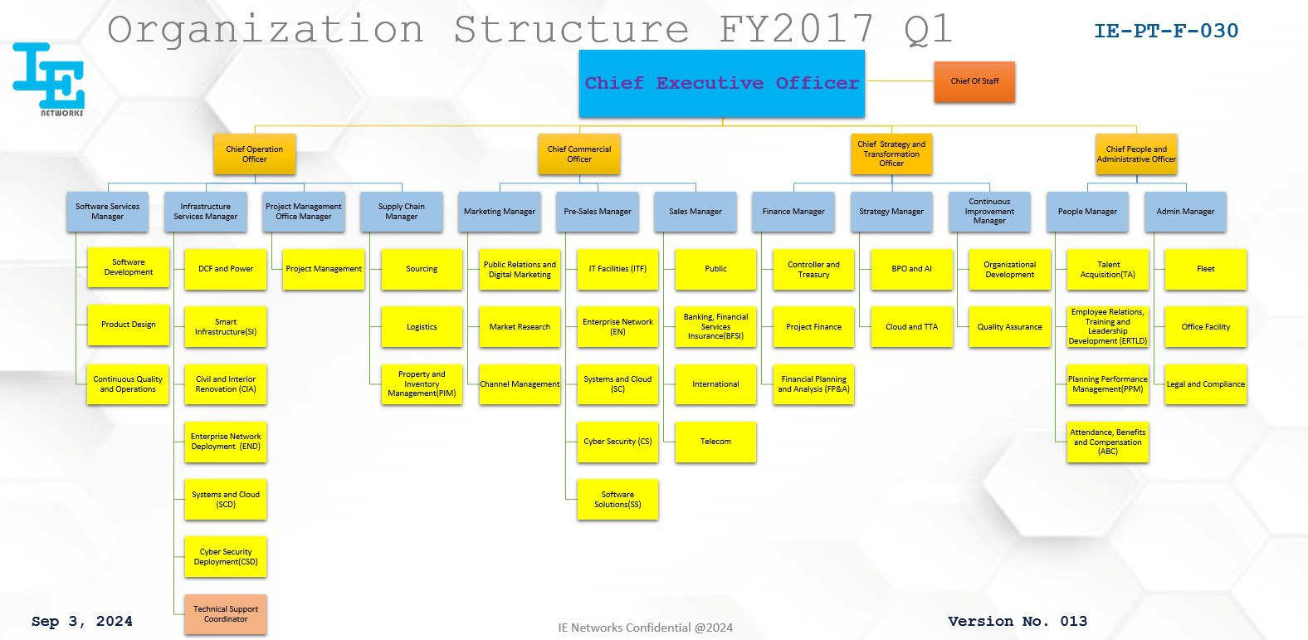

Fig. 1.1 Organization Structure of IE Network Solutions

### 1.2.2 Mission of the organization

**IE Network Solutions** is driven by a mission to become a world-class technology solutions and services provider that transforms the way businesses operate in Africa. Their commitment is to change the life of Africa through a disciplined work culture and systems thinking. By fostering excellence and innovation, IE Networks aims to revolutionize business practices and drive significant progress across the continent. Their mission reflects a dedication to enhancing technological capabilities and delivering impactful solutions that contribute to Africa's growth and development.

### 1.2.3 Products/ services of the organization

**IE Network Solution** provides a wide range of technology solutions and services designed to enhance business operations across Africa:

* **Data Center and Cloud Solutions**: Including compute, storage, virtualization, cloud automation, and disaster recovery.
* **Business Automation and Intelligence**: ERP systems, analytics, automation, and digital office solutions.
* **Smart Infrastructure**: Structured cabling, IoT solutions, and safety/security systems.
* **Network and Cybersecurity**: SOC services, network security, endpoint protection, and cybersecurity assessments.
* **BPO and ITO Services**: Frontend/backend development, API development, database management, DevOps, testing, and technical support.

# Chapter 2: Management, training, and employee information

## 2.1 Major duty

During my internship at IE Network Solutions, I joined the Software as a Service (SaaS) team, where my primary responsibility was to collaborate with fellow interns on the development of a **Vacancy and Employment Management System** designed to simplify and streamline the recruitment process. This system allowed HR teams to post job vacancies, review applications, manage hiring stages, and track job seekers' progress from submission to interview and job offer. My focus throughout the internship was on backend development, building the server-side infrastructure that powers these critical functionalities.

The internship lasted approximately two months, during which I concentrated on mastering backend technologies. In the first few weeks, I focused on strengthening my skills with **Node.js**, **Express.js**, and **PostgreSQL**, which served as the foundation for building robust APIs and handling data efficiently. I was responsible for implementing the system's core functionalities, such as creating, updating, and deleting job posts, managing applications, and tracking the hiring process.

As part of my role, I worked on creating APIs that enabled HR teams to interact with the system, from posting job listings to reviewing and processing applications. This required designing the database schema and relationships using **TypeORM** and managing complex data operations for tasks like job categorization, role assignments, and user authorization.

I also focused on implementing secure authentication and authorization features, ensuring that users had the correct permissions to access various parts of the system. This involved using **JWT (JSON Web Tokens)** for secure authentication and integrating role-based access control, allowing different roles (such as HR leaders, managers, and team leaders) to perform specific actions based on their permissions.

One of the key challenges was handling the complexities of the hiring workflow, which involved building features like job posting approval, interview scheduling, and applicant status tracking. Throughout the backend development process, I used **PostgreSQL** to design and manage the database, ensuring efficient data storage and retrieval for job posts, applicants, and interviews. I also integrated **TypeORM** to simplify the database management and to streamline operations across the system.

In addition to my backend responsibilities, I collaborated with the frontend team to ensure smooth communication between the client and server, providing the necessary APIs to power the system's interfaces. I also worked with tools like **Git** and **GitHub** to manage version control and facilitate collaboration within the team.

By the end of the internship, we had successfully developed a fully functional **Vacancy and Employment Management System using React, Tailwind,** **Node.js**, **Express**, **TypeORM**, and **PostgreSQL**, with secure authentication and a role-based access system in place. This experience not only enhanced my backend development skills but also gave me a deeper understanding of full-stack application development in a real-world SaaS environment.

## 2.2 Orientation of responsibilities

During our internship at **IE Network Solutions**, the system development team played an instrumental role in guiding us through the process of project execution, ensuring that we adhered to deadlines and delivered tasks on time. They stressed the importance of presenting our work formally to the team, providing valuable insights into effective project delivery and time management.

Additionally, we were given an orientation on the company’s day-to-day operations, emphasizing the value of fostering a collaborative and friendly atmosphere among employees. This understanding of cultivating a positive work culture and maintaining professional relationships with colleagues was invaluable to our development.

The team also educated us on the importance of punctuality, equipment maintenance, and professionalism in the workplace. They highlighted the significance of keeping our workspace organized, ensuring our equipment was in top condition, and showing respect to every individual to maintain a productive work environment.

Our supervisor played a crucial role in guiding us throughout the project, offering diverse perspectives, valuable ideas, and relevant resources. They shared lecture videos, assigned reading materials, and provided ongoing feedback, which significantly contributed to the successful completion of our tasks.

We also had the opportunity to apply our technical knowledge in a real-world setting. Our internship allowed us to work extensively on developing an Vacancy and Employment Management System , applying front-end and back-end technologies to build a robust web application. This hands-on experience was critical in advancing our programming skills and deepening our understanding of web development practices.

## 2.3 Supervisor ensures

Our supervisor played a crucial role in the success of our project, providing consistent guidance and support despite their busy schedule. Their dedication to our growth and the project was evident in their availability and commitment to ensuring we were on the right track. Beyond technical advice, they mentored us in project management and effective communication, equipping us with skills that extended beyond software development.

A significant aspect of their guidance was their advice on selecting the right tools for our development process, which streamlined our workflow and boosted productivity. One of the most impactful aspects of their mentorship was their detailed code reviews and feedback sessions. With their experience, they identified areas of improvement in our code, encouraging us to continuously learn and refine our work. This constructive feedback not only elevated the quality of our project but also fostered a growth mindset within our team, leading to a more polished and efficient final product.

## 2.4 Qualities Developed

During our internship at IE Network Solutions, we developed several important qualities:

* **Technical Skills**: We enhanced our expertise in both front-end and back-end development, including React, Tailwind CSS, Node.js, Express, PostgreSQL, and Type ORM. This hands-on experience solidified our foundation in building and managing complex systems.
* **Problem-Solving**: We cultivated a strong problem-solving mindset by tackling various challenges in both front-end and back-end development. This involved analyzing requirements, identifying solutions, and implementing effective strategies.
* **Project Management**: We learned to use project management tools like version control systems like Git. This experience improved our ability to organize tasks, track progress, and collaborate efficiently.
* **Responsive Design**: We developed the ability to create responsive web pages, ensuring a seamless user experience across various devices and screen sizes.
* **Time Management**: We learned to manage our time effectively, balancing multiple tasks and meeting project deadlines, which is crucial for success in a professional environment.
* **Collaboration and Communication**: Working closely with our team, we strengthened our collaboration and communication skills, improving our ability to share ideas and work together towards common goals.
* **Quality and Professionalism**: We learned the importance of delivering high-quality work, adhering to best practices, and maintaining professionalism to meet the standards of IE Network Solution.

# Chapter 3: Specific Job Information

## 3.1 Technical duties

During my internship at IE Networks and Solutions, I was responsible for several backend-focused tasks in developing the **Vacancy and Employment Management System** ,. My duties included:

* **Backend Development**: I developed and maintained the server-side of the system using **Node.js** and **Express**. This involved setting up APIs to handle various functionalities such as job postings, user management, and applications processing.
* **Database Management**: I managed the system's database using **PostgreSQL**, where I designed and implemented data models that supported the system’s key functionalities like job posts, user roles, and employee information. I also performed database migrations and optimized queries for efficient data retrieval and storage.
* **API Development**: I built and integrated **RESTful APIs** to enable communication between the front end and the back end. These APIs were responsible for handling actions such as creating, updating, and managing job posts, user authentication, and role-based access control.
* **Authorization and Authentication**: I implemented user authentication using **JWT (JSON Web Token)** and role-based access control, ensuring that users with different roles (HR, manager, team leader, etc.) had appropriate access to specific features of the system.
* **Error Handling and Debugging**: I identified, diagnosed, and resolved bugs and issues in the back-end codebase. This involved troubleshooting API failures, fixing database inconsistencies, and ensuring the smooth operation of server-side logic.
* **Security Best Practices**: I ensured data security by employing measures such as hashing passwords using **bcrypt** and securing endpoints with token-based authentication to protect sensitive user information.
* **Version Control**: I used **Git** for version control, which enabled smooth collaboration with other team members. I committed code regularly and managed different branches to ensure organized and conflict-free development.
* **Performance Optimization**: I optimized backend processes, such as query performance in PostgreSQL, to handle large datasets efficiently and reduce latency in the system’s response times.
* **Continuous Learning**: Throughout the project, I actively expanded my knowledge of **Node.js**, **Express**, and **PostgreSQL**, while also exploring more advanced backend topics such as database indexing, optimization, and best practices in API security.

## 3.2 Other responsibilities

In addition to our technical duties, we had several important responsibilities:

* We worked closely with fellow interns and system development team members, engaging in idea sharing, providing feedback, and collaborating to achieve the project’s goals.
* We followed company policies and guidelines related to coding standards, version control practices, and project management procedures. This adherence ensured consistency and coherence throughout the development process.
* We worked hard to manage our time and prioritize tasks, including research, design, development, testing, and debugging. Despite our efforts, we were unable to finish the project within the original deadline, which taught us valuable lessons in time management and setting realistic goals.
* We were encouraged to engage in ongoing learning and skill development. This included exploring new technologies, attending workshops or training sessions, and staying updated on industry trends and best practices.
* We maintained a high level of professionalism in our interactions with colleagues and supervisors. Clear and concise communication was essential for conveying ideas, reporting progress, and seeking guidance when needed.

## 3.3 Technical knowledge

At **IE Networks and Solutions**, I gained a broad range of technical knowledge, with a strong emphasis on backend development, including:

* **Back-End Development**: I developed proficiency in building server-side applications using **Node.js** and **Express**. I implemented RESTful APIs and set up the server-side logic to manage various aspects of the system, such as job postings, applications, and user authentication.
* **Database Management**: I acquired expertise in **PostgreSQL** for managing and structuring relational databases. I worked extensively on creating and optimizing database schemas, handling migrations, and ensuring efficient data storage and retrieval for the system.
* **API Development and Integration**: I gained a solid understanding of API design and development. I developed and integrated **RESTful APIs** that enabled smooth communication between the front end and the back end of the Vacancy and Employment Management System .
* **Authentication and Authorization**: I implemented secure authentication mechanisms using **JWT (JSON Web Token)** for user login and role-based access control, ensuring that different user roles had appropriate access to the system’s features.
* **Error Handling and Debugging**: I honed my skills in debugging backend issues and implementing comprehensive error-handling strategies to ensure smooth server-side operations. This involved troubleshooting server-side errors and database inconsistencies.
* **Version Control with Git**: I became proficient in using **Git** for version control, enabling effective collaboration and ensuring that code changes were well-documented and tracked throughout the development process.
* **Security Best Practices**: I applied best practices for securing the system, including hashing passwords using **bcrypt**, securing APIs, and protecting sensitive data through token-based authentication.
* **Performance Optimization**: I learned to optimize database queries and backend processes to improve system performance and scalability. This included reducing query execution times and ensuring that the system could handle large data volumes efficiently.
* **Continuous Learning**: Throughout the internship, I engaged in self-directed learning to deepen my understanding of **Node.js**, **PostgreSQL**, and best practices in backend development. This commitment to continuous learning helped me contribute effectively to the project.
* **Documentation**: I was responsible for documenting backend processes, including API specifications, database schema design, and code implementations. This documentation was essential for ensuring consistency across the team and providing a reference for future development.

## 3.4 Relevant projects

During our internship at IE Network Solutions, we were deeply involved in the development of an **Vacancy and Employment Management System** , designed to streamline recruitment and employee management processes. This project was a comprehensive solution that combined front-end and back-end development, allowing us to contribute to its successful completion.

The Vacancy and Employment Management System aimed to simplify various HR tasks, such as job postings, applicant tracking, and employee management. It was designed to enhance efficiency, enabling HR teams to manage recruitment and onboarding processes in a more structured and organized manner. The system’s user-friendly interface made it easy for HR staff to create job listings, review applications, and track employee information.

Key features of the Vacancy and Employment Management System included:

1. **Job Posting Management**: The system allowed HR and other team’s leaders to create, update, and manage job postings. This feature enabled seamless integration of job requirements, departments, and locations, providing a central hub for all recruitment-related activities.
2. **Applicant Tracking**: HR teams and other teams could track applications and review candidates’ information, such as resumes, cover letters, and application status.
3. **Employee Data Management**: The platform allowed **Manager** to manage employee information, including personal details, team assignments, and roles. This centralized database ensured that employee data was easily accessible and could be updated in real-time.

In developing the Vacancy and Employment Management System , we utilized a robust technical stack:

* **Front-End Development**: We used React and Tailwind CSS to build an intuitive and responsive user interface. This allowed for dynamic interactions and ensured the platform was accessible on various devices.
* **State Management**: React Hooks (useState) was employed to manage the state of the application, ensuring a seamless user experience across the system.
* **Back-End Development**: The server-side logic was handled using Node.js and Express, which provided efficient data processing and ensured that the platform could handle multiple requests simultaneously. PostgreSQL was used for database management, offering a reliable and secure way to store and retrieve data.
* **Version Control and Collaboration**: Git was employed for version control, enabling team collaboration and maintaining the integrity of the code base.

Throughout the project, we worked collaboratively with team members, ensuring that our efforts were aligned with the project's overall goals. We documented our progress, to keep track of development milestones and facilitate future improvements.

The job posting pages are listed below

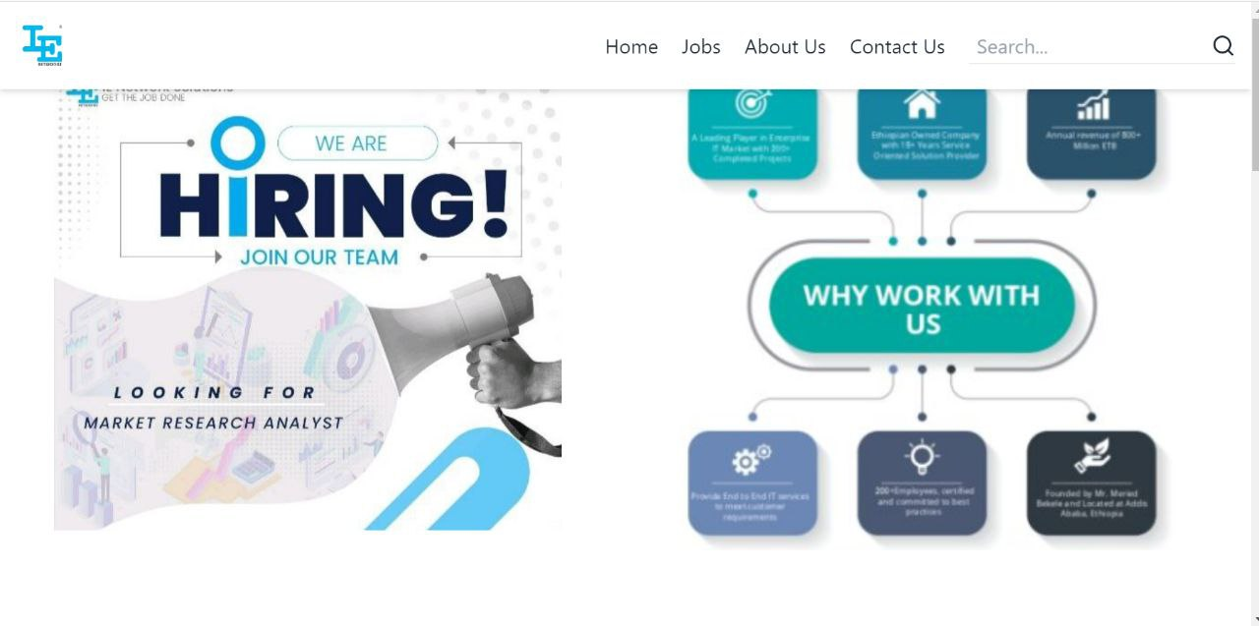

Fig. 3.1:- Home page (show as why the applicant can work with the company)

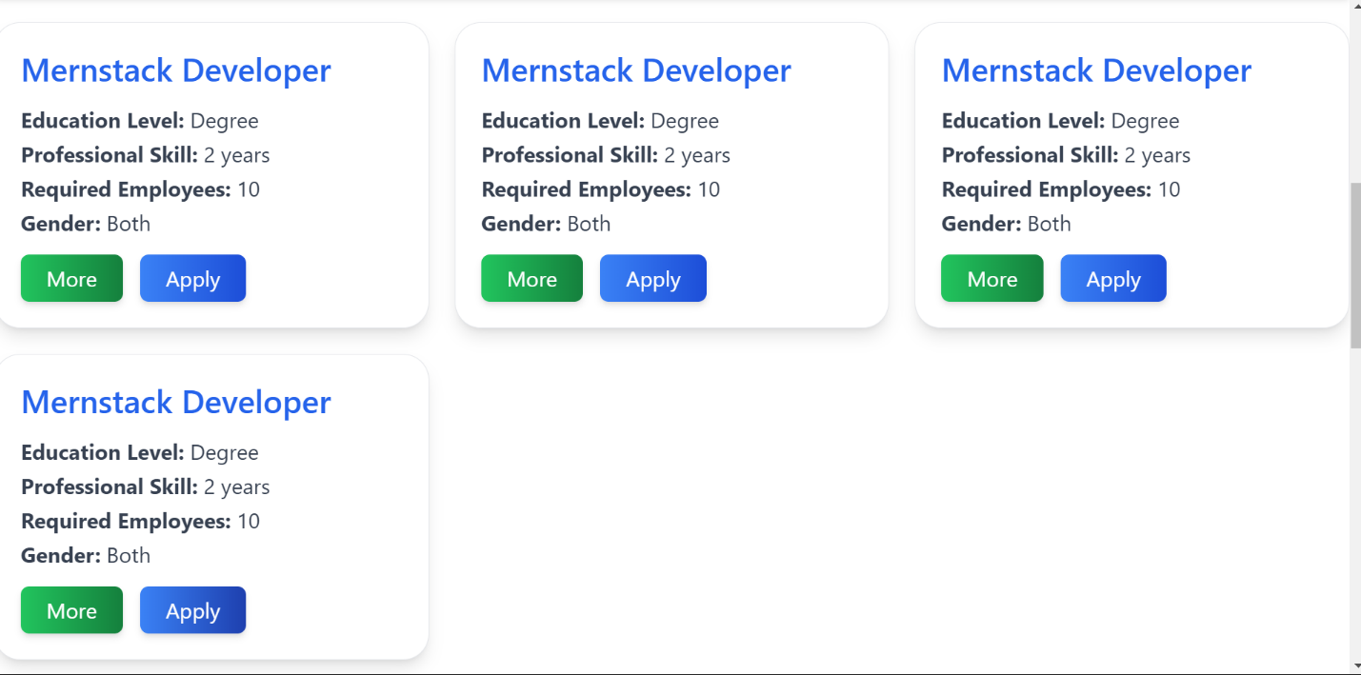

Fig. 3.2: Posted job view page( display the jobs posted by the HR)

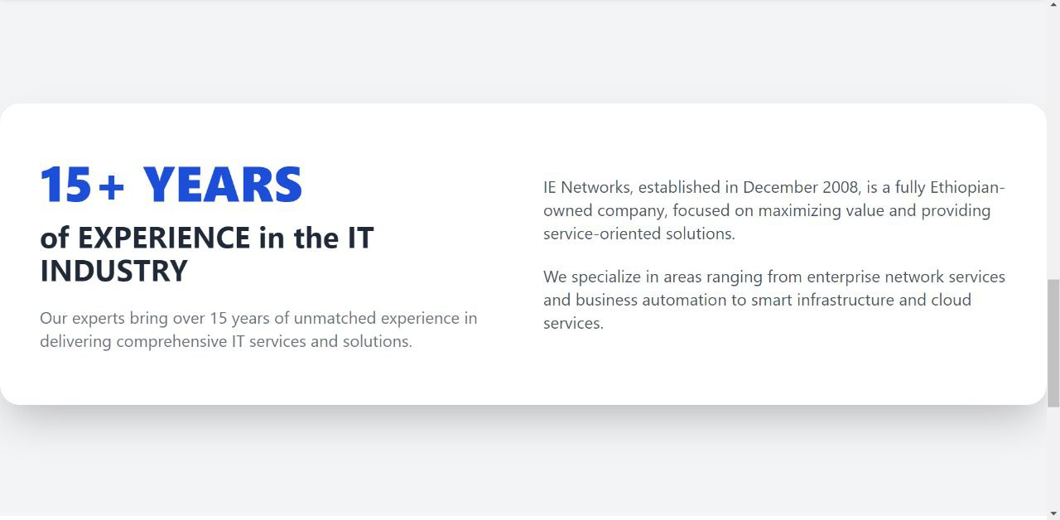

Fig. 3.3: About Us page (give a little information about the company)

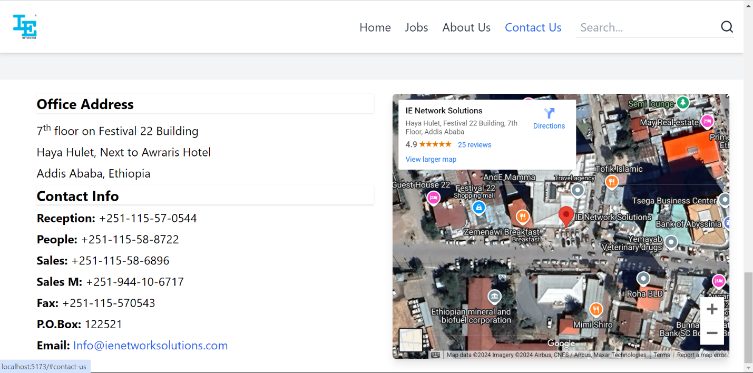

Fig. 3.4: Contact us page (contact info of the company)

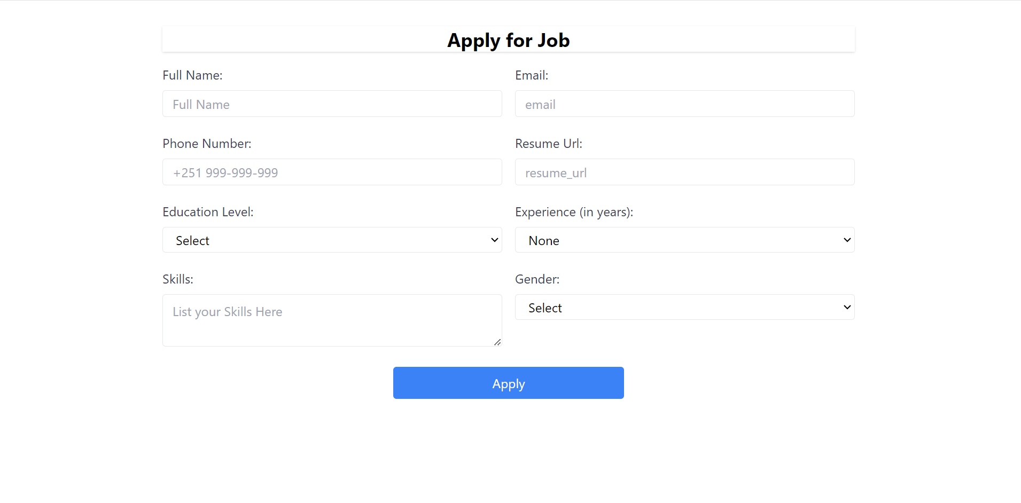

Fig. 3.5: Apply for job page (page to fill information of the applicant)

Each team leader pages are listed below

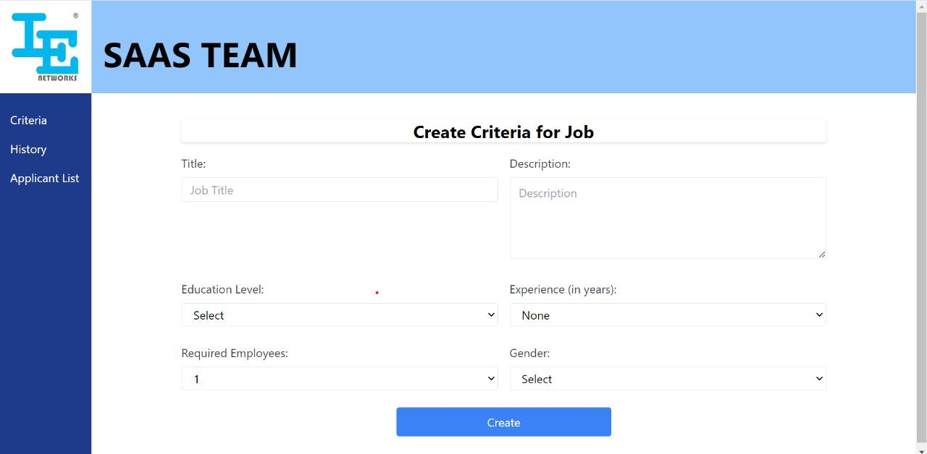

Fig. 3.6: Criteria Creation Page (used to create the criteria of the job to be posted)

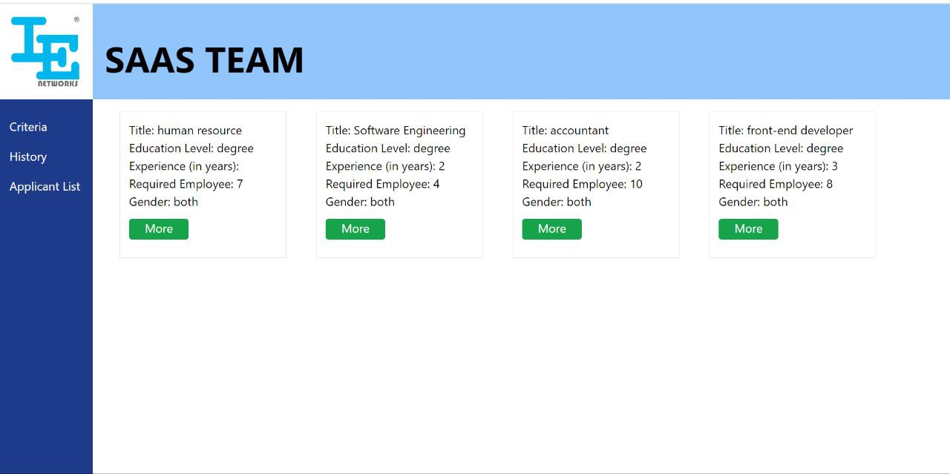

Fig. 3.7:- Created Criteria History Page (display approved jobs by the manager for each team leader)



Fig. 3.8:- View Post Page (this page is available only for the HR. it display the jobs that is approved by the manager)

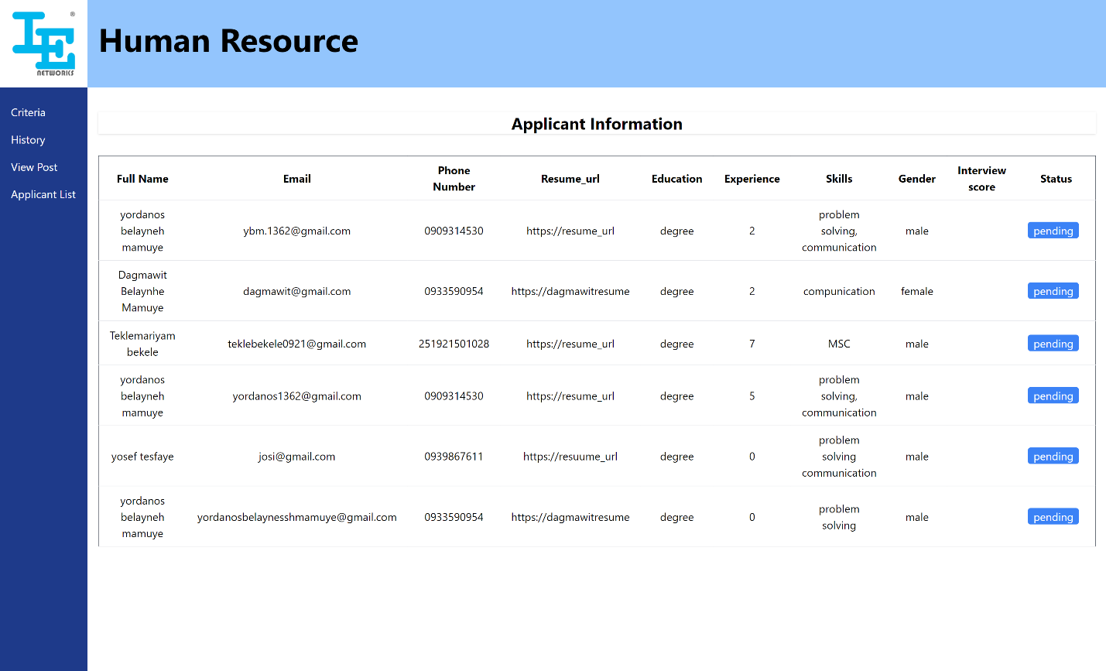

Fig. 3.9:- Applicant List Page (HR’s and team leaders can view applicant lists in each specific post)

Manager pages are listed below

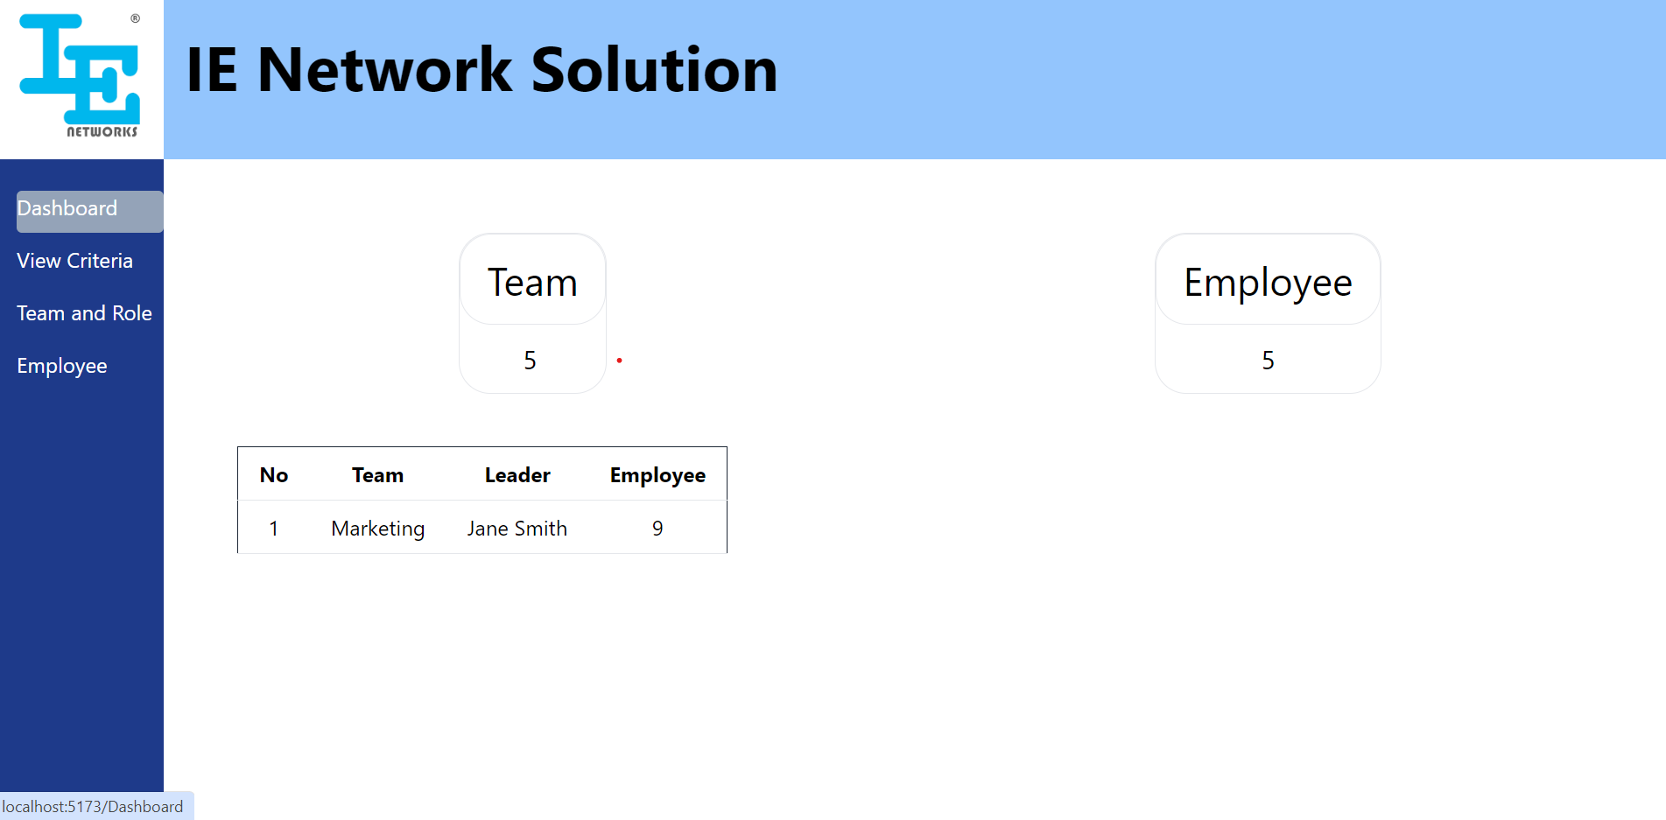

Fig. 3.10:- Dashboard (Display the number of total teams and employees, and other information)

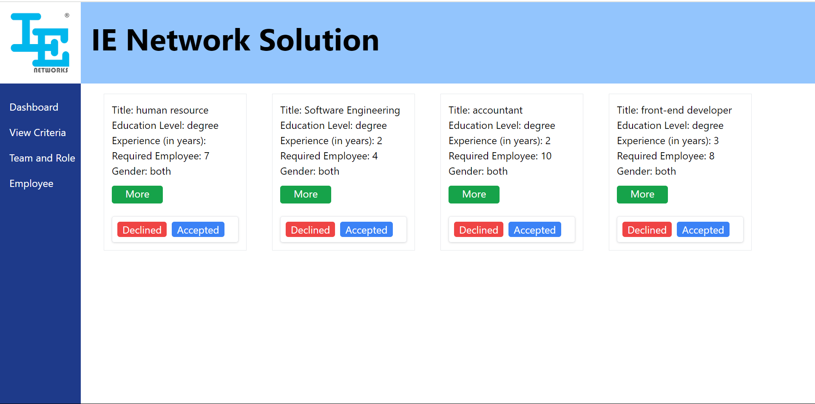

Fig. 3.11:- View Criteria page (Manager can view job criteria created by team leader and give decision either “declined” or “accepted”)

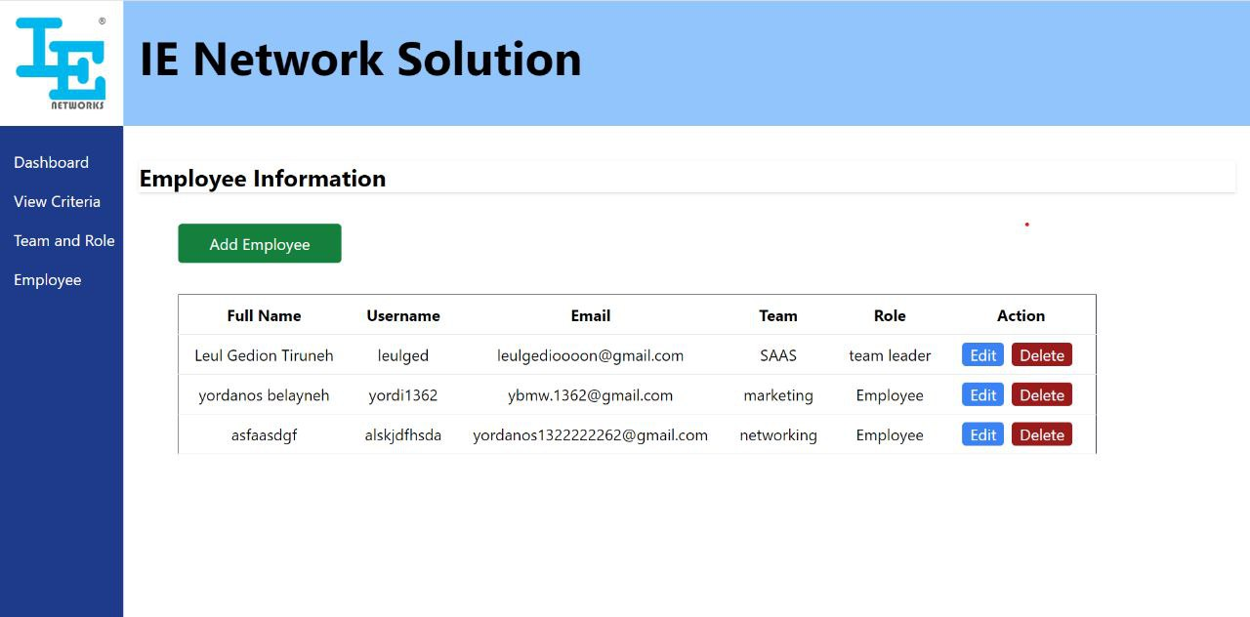

Fig. 3.12:- Employee display page (can display added employees)

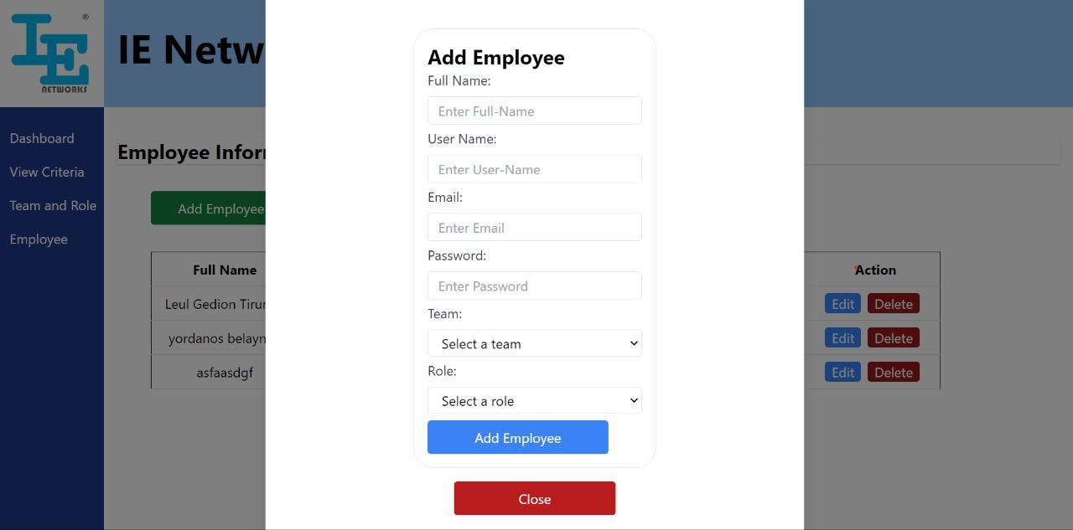

Fig. 3.13:- Add Employee page

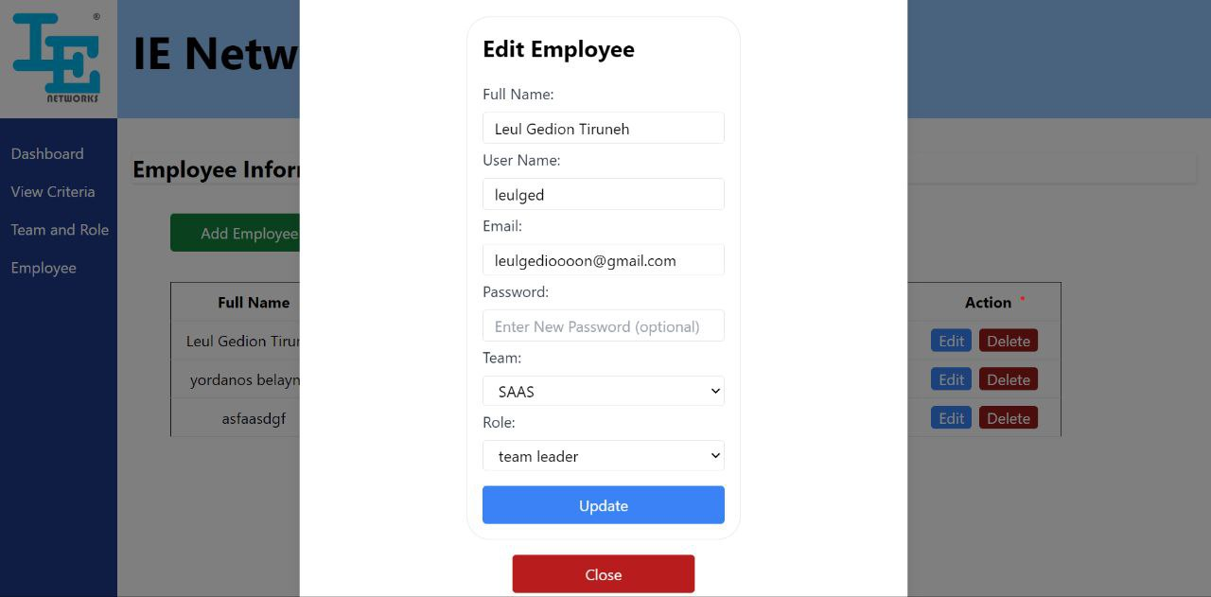

Fig. 3.14:- Edit Employee page

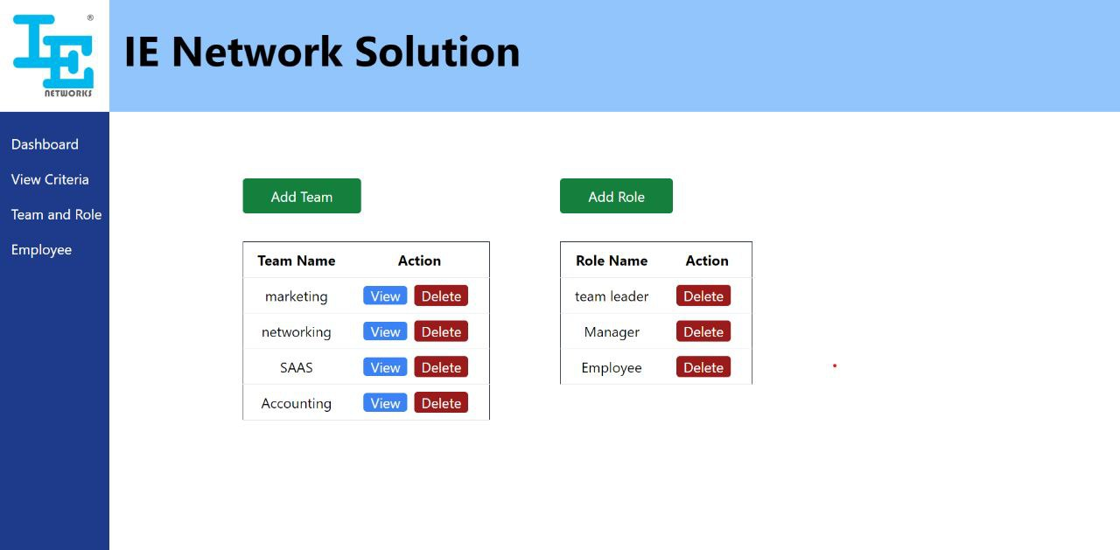

Fig. 3.15:- Team’s and Role’s view page (Display both the role’s and teams of the company

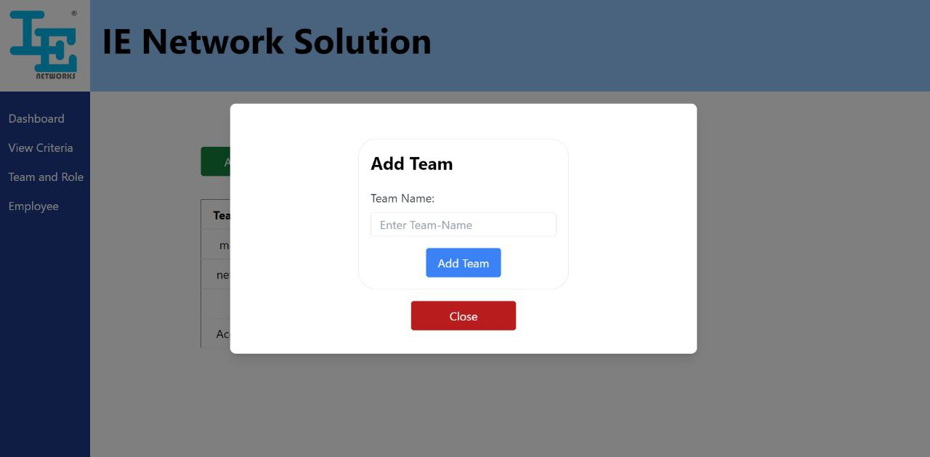

Fig. 3.16:- Add team page

# Chapter 4: Reflection and Conclusion

## 4.1 Evaluation and Critique

Our internship experience at IE Network Solutions was transformative and highly educational. Initially, there was a sense of apprehension about transitioning from theoretical knowledge to real-world applications. However, as we immersed ourselves in the internship, we witnessed a substantial improvement in our understanding of how the industry operates. The experience allowed us to bridge the gap between academia and the practical demands of the workforce.

The support extended to us by the employees at IE Network Solutions was invaluable. Despite the fact that our supervisor was often busy, she ensured that a member of the team regularly checked in on us. This guidance and the advice they shared were instrumental in shaping our career trajectory and preparing us for future challenges. Their willingness to mentor us, despite their own workloads, helped us build confidence, develop problem-solving skills, and approach our tasks with greater proficiency.

While the journey was rewarding, we felt that additional attention from the team during certain stages would have enriched our learning experience even further. Being able to work more closely with the team, particularly during critical project phases, could have provided deeper insights into the intricate aspects of their work. Nevertheless, the knowledge and skills we gained during this short period, both technical and soft skills, were substantial.

## 4.2 Career goal during internship

The internship experience at IE Network Solutions played a significant role in shaping our career aspirations. Prior to this opportunity, our career goals were somewhat undefined, and we lacked a clear direction for our future. However, through the guidance and support we received during the internship, we began to gain clarity on what we want to pursue professionally.

The team at IE Networks emphasized the importance of identifying our career paths early on, and they provided valuable advice on how to improve our skills and navigate the professional world. Their insights on career development have been instrumental in helping us figure out what we truly want to do in the future. Their encouragement and mentorship have given us the confidence to explore our interests further and make more informed decisions about our career paths.

## 4.3 Value of internship

The internship experience at IE Network Solutions has had a significant and lasting impact on us. It provided a unique opportunity to immerse ourselves in a real-world professional environment, greatly boosting our confidence and understanding of the workplace. The exposure to practical scenarios and the hands-on experience we gained during the internship has been invaluable in preparing us for the next steps in our careers.

This internship transformed our perspective, enhancing not only our technical skills but also our soft skills, such as communication, teamwork, and problem-solving. The guidance and mentorship from the team, even when they were busy, were immensely helpful in shaping our professional outlook. We learned the importance of defining career goals early and received insightful advice on how to continuously improve and grow within the industry.

We are incredibly grateful to IE Networks for providing this opportunity and for their support throughout the program. The lessons and experiences we have gained from this internship will have a lasting impact on our future careers, equipping us with the confidence and skills needed to navigate the professional world.

In addition, this internship experience has also reinforced the importance of hands-on learning, not only for us but for our peers as well. The exposure to the challenges and dynamics of the professional world has been a crucial aspect of our growth, and we are eager to apply these valuable lessons in our future endeavors.

## 4.4 Challenges we faced during the internship

One of the challenges I faced during the internship at IE Networks was related to transportation, but unlike typical issues with commuting in the morning, my challenge was in the evening. After a lengthy day at the office, finding transportation to return home was often difficult, which added an extra layer of fatigue at the end of the workday.

Additionally, like many interns, I initially struggled with self-confidence when engaging in tasks or collaborating with established professionals. Over time, however, I became more comfortable interacting with the team and gradually built confidence through experience and mentorship.

Another significant challenge was the length and intensity of the learning path. The technologies we were expected to learn, while valuable, were extensive, and the timeline of two months felt rushed. Implementing new tools and frameworks within this tight schedule was tough. However, with the help and support of my supervisor and team members, I was able to overcome this hurdle and gradually grasp the concepts, even though the process felt condensed.

Despite these challenges, the experience was invaluable and demonstrated the importance of persistence, adaptability, and seeking help when necessary.

## 4.5 Strengths and areas of improvement

### 4.5.1 Strength

* **Punctuality:** We adhered to the working hours from 7:00 a.m. to 4:00 p.m., consistently arriving on time and maintaining discipline throughout the day.
* **Discipline and Work Ethic:** We followed the organization's rules and respected its work culture, ensuring that we stayed focused and met expectations.
* **Good Work Habits:** We developed strong work habits, including effective time management and organization, which helped us stay productive.
* **Teamwork:** We worked well with others, collaborating effectively with employees and fellow interns, which contributed to a smooth workflow.
* **Respect for Colleagues:** We maintained respectful interactions with other employees, fostering a positive and professional work environment.

### 4.5.2 Areas of Improvements

Throughout the internship, we observed some challenges that need attention from both students and the involved institutions. Some students seemed disengaged during working hours, lacking the drive and understanding of the internship's significance. It's essential that students are better informed about the value and purpose of internships, so they approach the experience with the right mindset.

On the institutional side, the Ministry of Education (MOE) or relevant authorities need to reconsider and enhance the internship curriculum. Many students face difficulties securing placements, and even when they do, some organizations are not fully prepared to provide meaningful guidance. This can hinder students from gaining valuable real-world experience.

That being said, there are also companies that go above and beyond, offering substantial support to interns and helping them bridge the gap between academic learning and practical work. These organizations deserve recognition and appreciation for their efforts in shaping the future workforce. We are deeply grateful to those who provided us with opportunities and guidance, helping us prepare for the next steps in our professional journey.

## 4.6 Conclusion

The internship at IE Network Solutions gave us practical experience that enhanced our academic knowledge, bridging the gap between theory and real-world application. It improved our communication, teamwork, and problem-solving skills, while providing hands-on experience with industry tools. Although the experience was largely positive, more comprehensive training materials and continuous evaluation would improve the program.

In conclusion, this internship was crucial for our professional growth, giving us the skills and confidence needed for future career success. We are thankful for the guidance and opportunities provided, and we believe the experience will serve as a strong foundation for our future endeavors. Overall, it was a rewarding journey that we will carry forward in our careers.

# Chapter 5: Recommendations

## 5.1 Recommendation about the organization

To enhance operations, improving coordination across all organizational levels is essential. This includes fostering better communication and collaboration between high-level management and lower-level employees to ensure alignment with company goals.

Furthermore, ensuring accessible and reliable transportation options for employees is crucial. A well-organized transportation system will facilitate punctuality, ease commuting, and enhance overall employee satisfaction and well-being.

IE Network Solutions is a hardworking organization with a disciplined team and a well-organized mission. I recommend this internship program to individuals seeking to improve their discipline and work ethic. Participants will not only gain valuable experience but also develop essential soft skills that are crucial for success in any professional setting. This commitment to personal and professional growth makes IE Network Solutions an excellent choice for aspiring interns.

## 5.2 Recommendation about internship

To enhance the internship experience, we propose the following recommendations:

1. The internship curriculum should be aligned with current industry needs, ensuring students gain relevant skills and knowledge.
2. Recognize internships as essential learning experiences, integrating them more fully into academic programs.
3. Educate students on the value of their internships, helping them understand how these experiences contribute to their career development.
4. Increase government initiatives to facilitate more internship placements, reducing the stress students face when seeking opportunities.
5. University supervisors should visit internship sites at least twice to monitor progress and provide guidance, or call to check in on the interns.
6. Stipends for interns should be increased to better support their financial needs during the internship period.

## 5.3 Suggestion

The internship experience at IE Network Solutions has been instrumental in developing our skills, providing real-world exposure, and fostering professional growth. The supportive environment, knowledgeable mentors, and practical learning opportunities make it an ideal choice for students seeking hands-on experience in the field.

We believe that this internship program can greatly enhance the academic and professional development of future interns.

Lastly, we extend our heartfelt gratitude to IE Network Solutions for their guidance and support throughout our internship journey.

# Reference

* Internship Guidelines for interns
* Old practical attachments
* our supervisor